Customer Questionnaire Concerning Non-Conforming Product by PROTON-ELECTROTEX, JSC

1. Customer information:

Date of issue: |  |  |  |  |  |  |  |  |  |  |  |  |  |  | Contact person:
Company name: |  |  |  |  |  |  |  |  |  |  |  |  |  |  | Phone:
Country: |  |  |  |  |  |  |  |  |  |  |  |  |  |  | Fax:
City: |  |  |  |  |  |  |  |  |  |  |  |  |  |  | Е-Mail:
2. Returned device:

№ |  |  |  | Type of device |  |  |  |  |  |  |  |  |  | Serial number |  |  |  |  | Release date |  | Date of the device delivery to the customer
1 |  |  |  | 2 |  |  |  |  |  |  |  |  |  | 3 |  |  |  |  | 4 |  | 5

3. Return due to technical reasons – Input testing of the device

* |  |  | electrical parameters do not conform to the technical requirements of the device
* |  |  | physical configuration does not conform to the technical requirements of the device
* |  |  | other:

4 Return due to technical reasons – Failure analysis request

4.1 The time of failure/defect detection:

* |  |  | during installation of new facilities
* |  |  | during start-up program of standard equipment, devices of PROTON-ELECTROTEX, JSC were used for the first time
* |  |  | during start-up program of standard equipment, devices of PROTON-ELECTROTEX, JSC were in operation before
* |  |  | during the operation:
 | * |  |  |  | < 1 year time of operation
 | * |  |  |  | ≥ 1 year time of operation
Other parts of the equipment (active/passive components) failed at the same time? If Yes, which?
4.2 Climatic storage/operational conditions:

Ambient air temperature:

Relative air humidity:

4.3 Defect/failure detection description (attach photo of device configuration in the converter):

If returning more than one device: Did all devices fail at the same time in
the same equipment? |  |  |  |  |  |  |  |  |  |  |  |  |  |  |  |  |  |  |  |  |  |  | Yes  (да) |  | No  (нет)
Has there been any similar failure of the equipment in the past? If Yes, point out.
4.4 Possible reasons for defect cause:

4.5 Type of testing and metering equipment used to check the parameters of the devices:

4.6 Type and description of equipment, in which the device operated:

4.7 Description of the operational conditions of the devices at the time of failure/defect detection (fill in section A in the attachment 1)

4.8 Connection diagram of the device (draw in section B or attach it separately)

4.9 Description of the thyristor control system ( fill in section C in the attachment 1)

4.10 Description of the cooling system:

Type of the cooler in use:

* |  |  | Liquid |  |  |  |  |  |  |  | Natural air |  |  |  |  |  |  | Forced air
Value of axial force compression:

Type of compressor:

Coolant temperature:

5. Commercial questions regarding the replacement

If the results show that the reason of the failure was the fault of the customer, then it is necessary:

* |  |  | to return the device
* |  |  | to dispose
* |  |  | other
6. Contact information of the originator:

* |  |  | mark «Х» next to the correct option

Attachment 1
(Приложение 1)
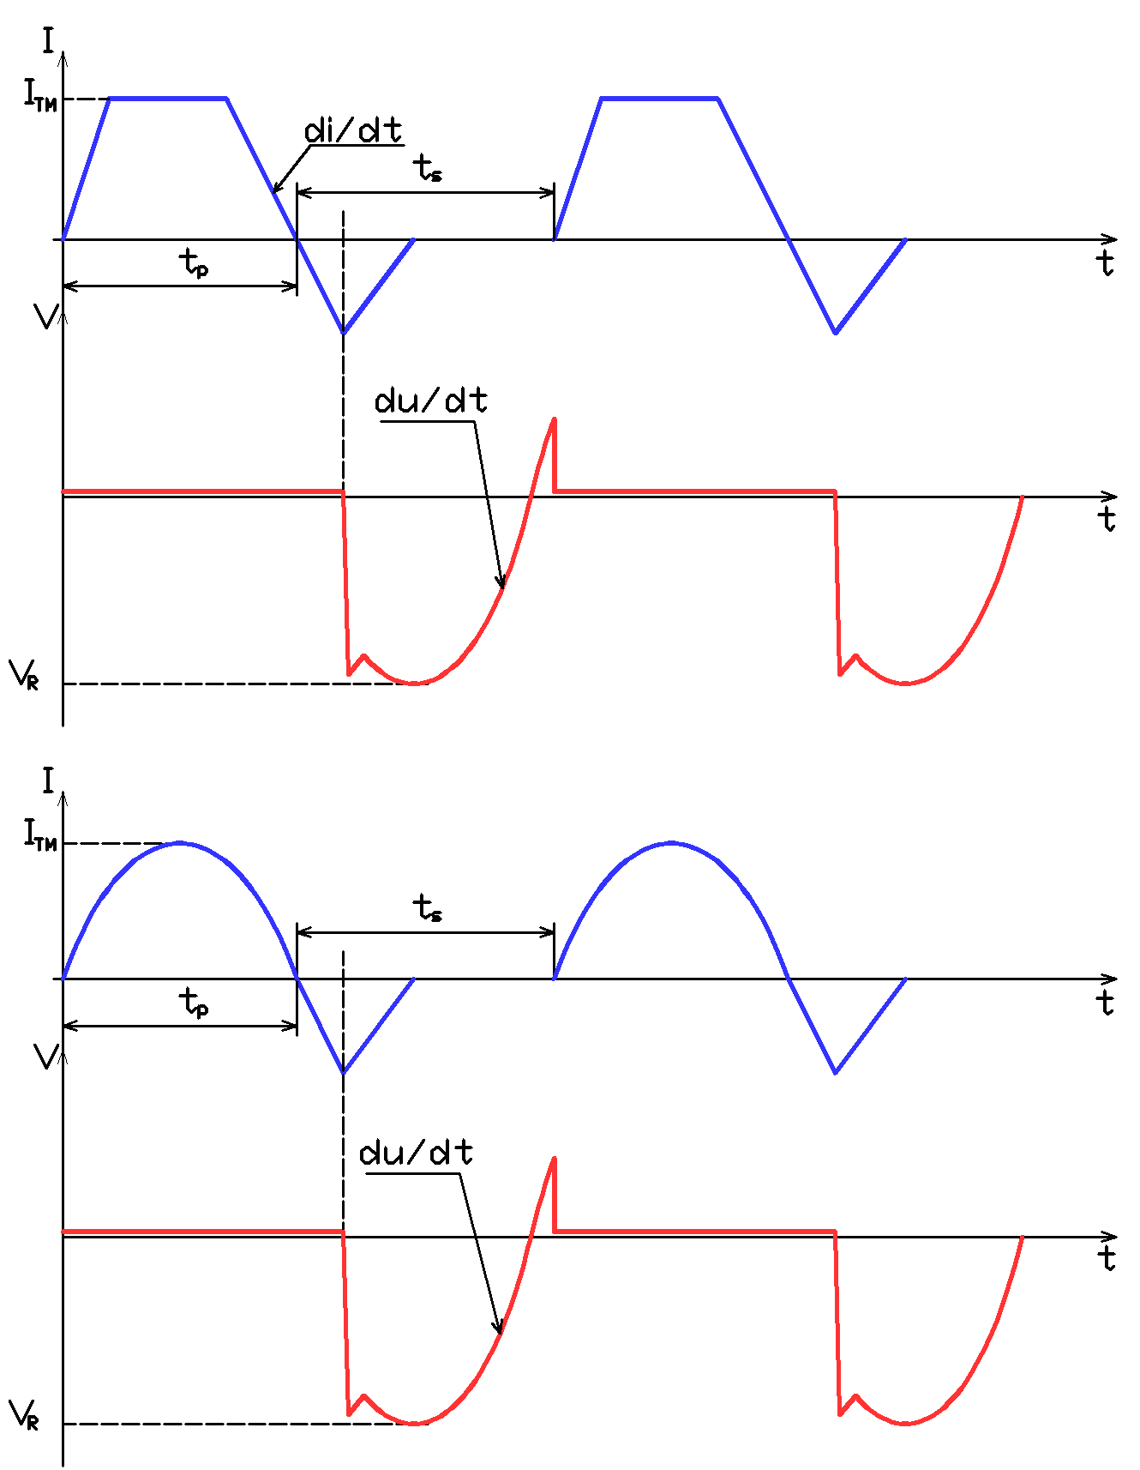  А - power circuit parameters  (параметры силовой цепи)  di/dt=  du/dt=  ITM=  tp=  ts=  VR= | В – electrical circuit  (электрическая схема)
I_{GM}=
I_{Gon}=
t_{f}=
t_{on}=
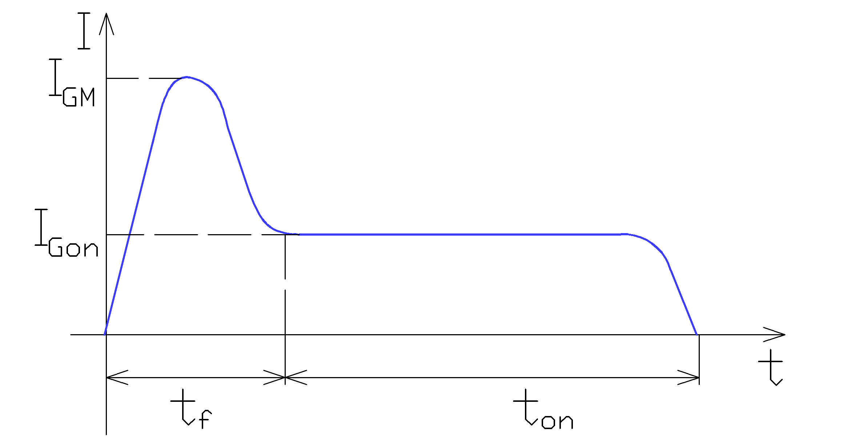
С – control circuit parameters
(параметры цепи управления)

